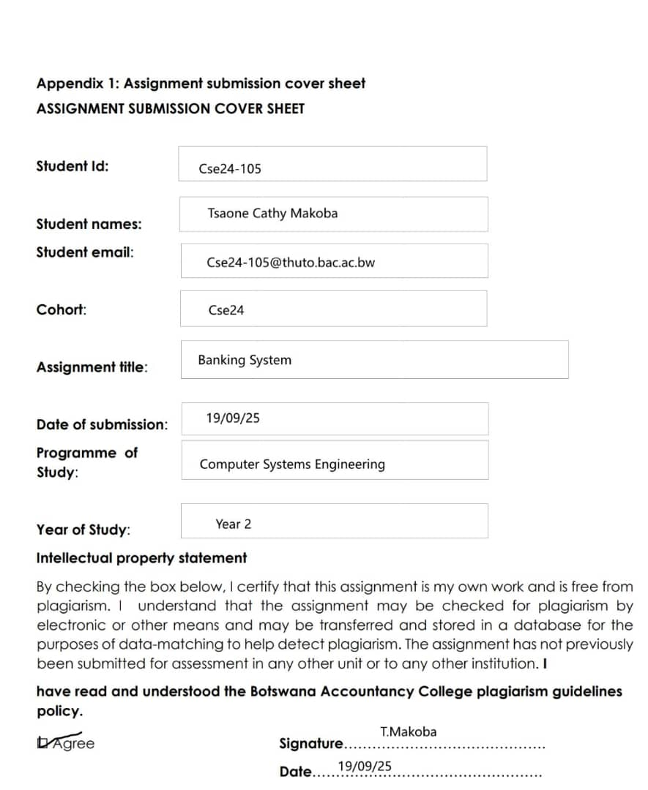

REQUIREMENTS ELICITATION

FUNCTIONAL REQUIREMENTS

1. **Account Creation:** The system **shall** allow a bank employee to create a new account for a customer. The system **shall** require the customer to select an account type (Savings, Investment, or Cheque) and validate the account-specific rules (e.g., a minimum initial deposit of BWP 500.00 for an Investment account).
2. **Deposit Transaction:** The system **shall** allow a customer to deposit funds into any of their active accounts eg the investment and savings accounts . The system **shall** update the account balance in real-time upon a successful deposit.
3. **Interest Calculation & Crediting:** The system **shall** automatically calculate and credit monthly interest to applicable accounts. The calculation **shall** be based on the account type and current balance:
   1. Investment Accounts at a rate of **5%** per month.
   2. Savings Accounts at a rate of **0.025%** per month for an individual and **0.075%** for a company
   3. Cheque Accounts **shall** receive **no** interest.
4. **Balance Inquiry:** The system **shall** allow a customer to view the current balance of any of their accounts.
5. **Withdrawal Transaction:** The system **shall** allow a customer to withdraw funds from their Investment or Cheque account. The system **shall** update the account balance in real-time upon a successful withdrawal.

NON FUNCTIONAL REQUIREMENTS

* **Transaction History & Retrieval:** The system **shall** record a log entry for every financial transaction (deposit, withdrawal, interest credit) made against an account. The system **shall** allow a customer to view a chronological history of all transactions for any of their accounts, displaying for each entry: the date, time, transaction type, amount, and resulting balance.
* **Security:** The Banking System will have a login where the user can login with their own passwords ensuring the safety of their accounts
* **Buttons:** should have colourful buttons and functional

Use Case Diagram

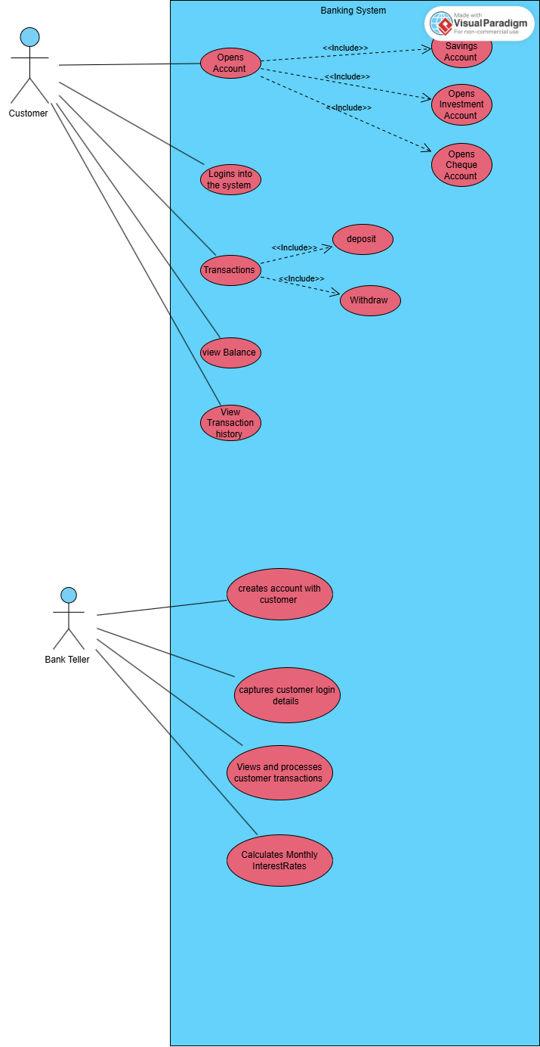

Class Diagram

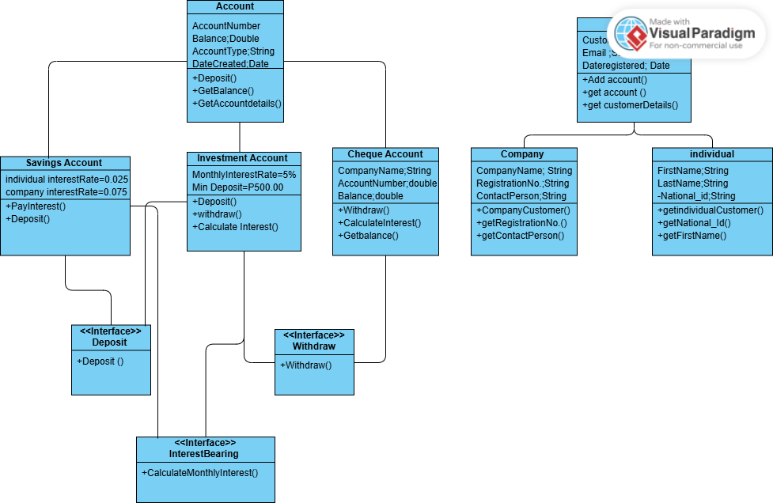

BEHAVIOURAL DIAGRAM MODELLING

Login

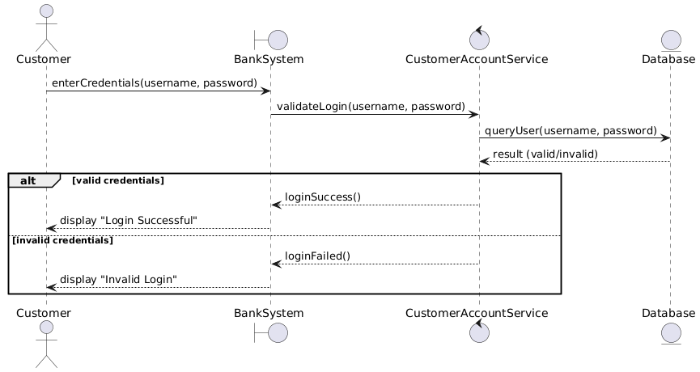

Deposit

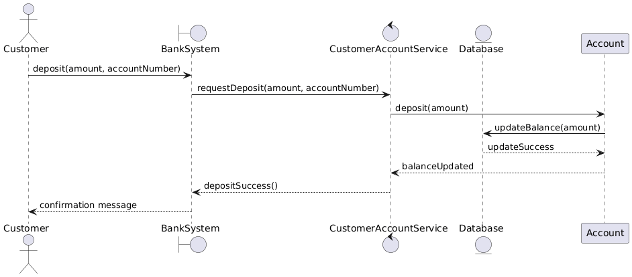

STATE DIAGRAM

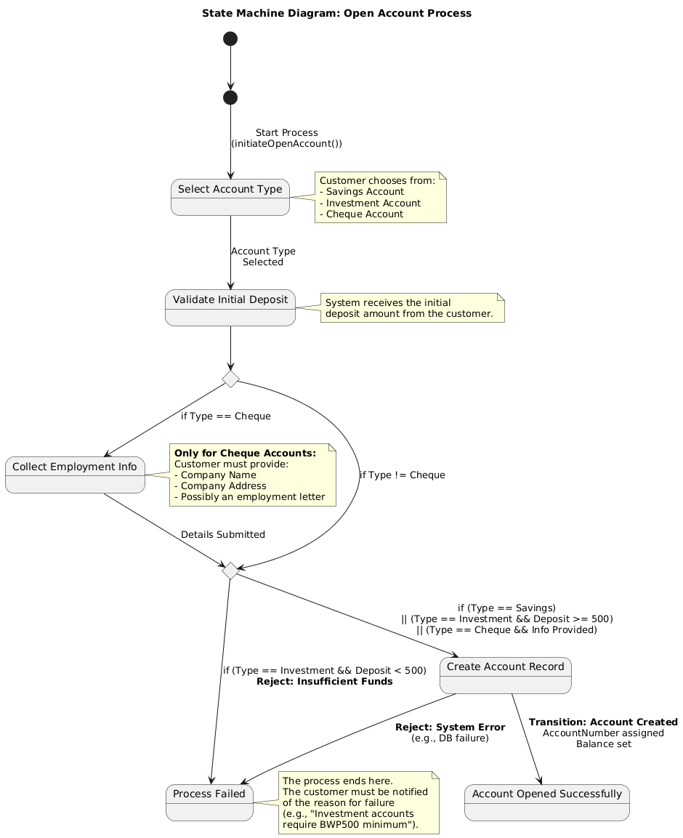

### **Appendix A: Interview Record**

**1. Interview Details**

|  |  |
| --- | --- |
| **Item** | **Detail** |
| **Interview Topic:** | Requirements Elicitation for Banking System |
| **Interviewee (Client):** | Kentsenao Baseki |
| **Interviewer (Analyst):** | [Tsaone Cathy Makoba ] |
| **Date & Time:** | [18 September 2025, 10:30] |
| **Duration:** | [1030-1230] |
| **Mode of Interview:** | [ Microsoft Teams Call] |

**2. Interview Objectives**  
The primary objectives of this interview were to:

* Clarify the core functional requirements for the proposed banking system.
* Understand the non-functional requirements, particularly regarding security and usability.
* Identify any constraints or specific rules governing different account types.
* Gain a clear understanding of the client's vision and expectations.

Questions and Answers

1. Should the month monthly interest should require human approval before finalization or they should be fully automated?

Answer; it must be fully automated

2.Customer Information

Question: what specific , critical information should be stored for individual customers and for company

Answer; For individuals it should be NationalID,date of birth and contact number

Question3

Transactional History

Question , after the system is automated should it record the transactional history

Answer

It shall record and should show the date , interest amount creditated and the new balance